**PLTW Activity 1.4.2**

**Notes**

Image files are recorded as binary and can be modified by “simple” actions (e.g., enlarging, rotating, brightening, etc.). These actions are complicated operations that entail millions of calculations.

An absolute filename includes the entire directory pathway to access the specified file, as opposed to the relative filename that is specified only from the current working directory. Most operating systems and programming languages recall one location in your file system as your “working directory,” and a file can be described relative to that location aka relative filename (i.e., a filename or path for reaching the file’s directory, commencing from the current working directory.

Most file systems are hierarchical, forming a tree (i.e., a data structure in which each node has exactly one parent, except for the root node, which has no parent) that instigates with a root directory.

Files and directories are nodes, elements in a tree, each branching from one parent, an element in a tree data structure that is the immediate ancestor of another element, in the tree, with the root considered the “top” of the tree.

An escape character allows a programmer to display characters that might otherwise be difficult for the programmer to enter or display, such as tabs, quotes, and new lines. Generally, an escape sequence begins with the “\” character. Escape characters are multi-character codes that allow you type single characters that would be invisible or would have other effects.

Interactive graphics user interfaces are the dominant method for designing human-computer interaction.

A class is an abstraction defining an object with methods and attributes. An object is a specific instance of a class with a specific set of values for its own attributes that can execute any methods defined in its class. Methods are sets of instructions that are grouped together to perform something pertaining to an object. An instance is a single object of a specific class. Interpolate is to determine intermediate or middle values between data points or in the case of this assignment, between values of image pixels.

An Application Programming Interface (API) is the way programmers communicate and simplify their code with other programmers. In object-oriented libraries, an API specifies the methods of each class.

**Journal**

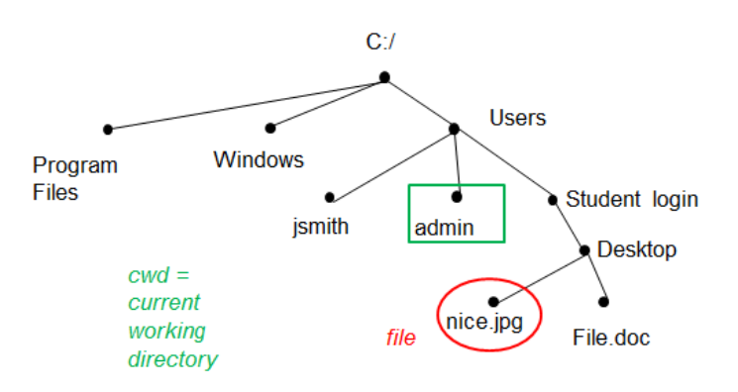

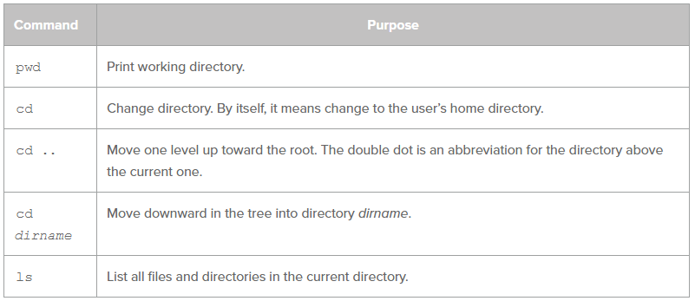

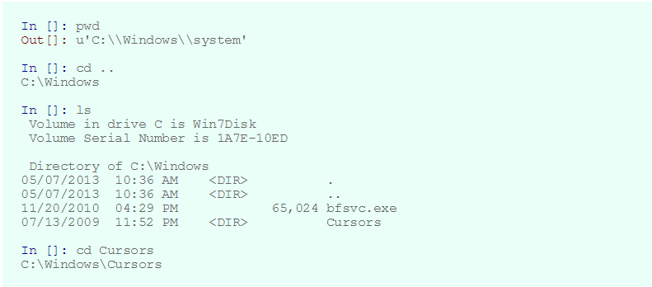

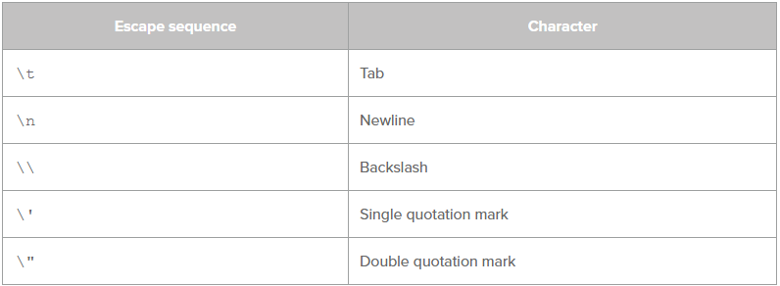

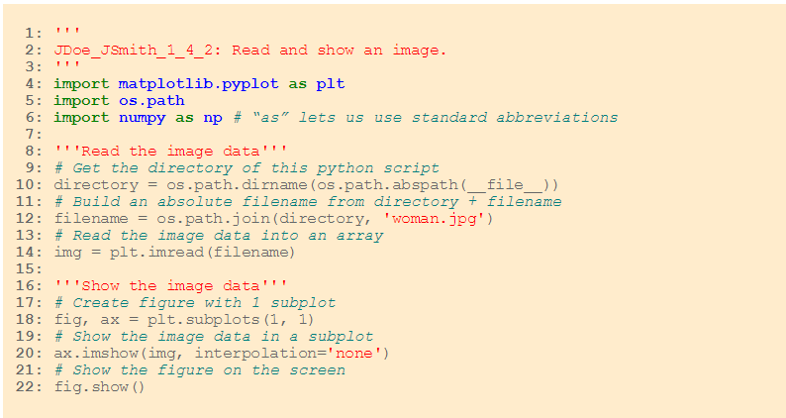

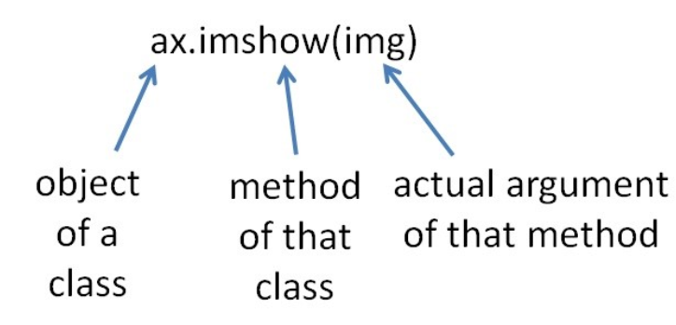

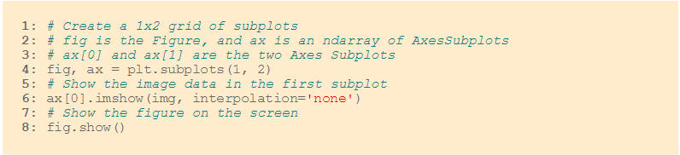

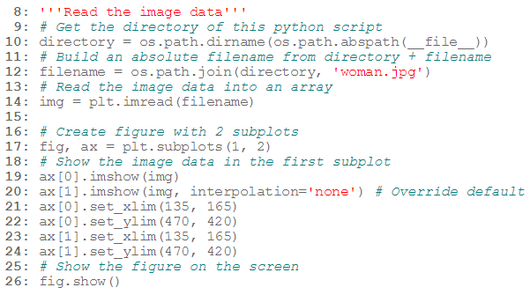

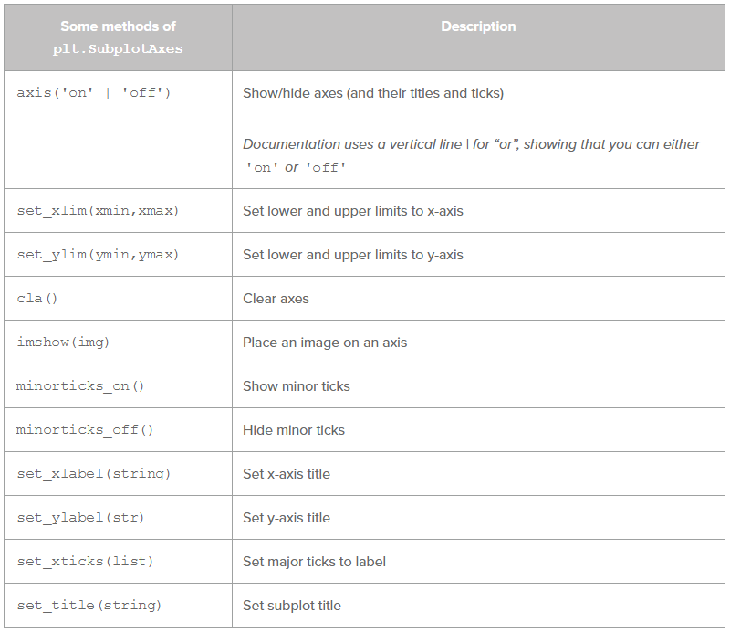

**Conclusion**

1. Describe similarities and differences between absolute filenames and relative filenames. An absolute filename entails the entire directory pathway to reach the specified file, whereas a relative filename is specified only from the current working directory.
2. What is an object? An object is an instance of a class that may possess its own set of attributes and is able to execute any methods defined in its class.
3. Objects have methods and properties. What are methods and properties? A method is an accumulated set of instructions that performs something pertaining to an object. A property is a set of variables with potentially unique values for each object.
4. What happens when you call a method on an object? When an object calls a method, the method is assigned an argument derived from the object’s attributes.

**PLTW Activity 1.4.3**

**Notes**

Lists and tuples are slower than arrays, but are capable of mixing various data types, including strings and integers. An RGB color image is constructed of pixels of three color intensities. An alpha channel is Part of a pixel's data that specifies how opaque or transparent that color should appear when the graphics card calculates how to render the image on screen.

**Journal**

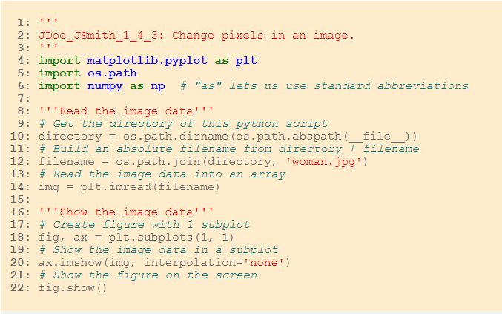

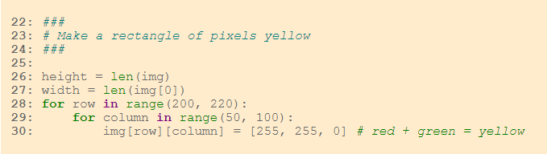

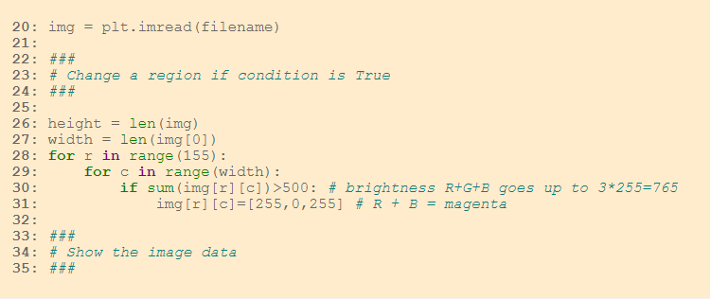

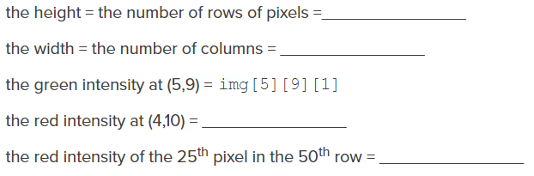

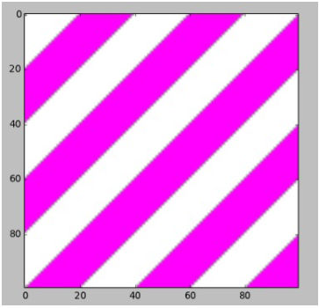

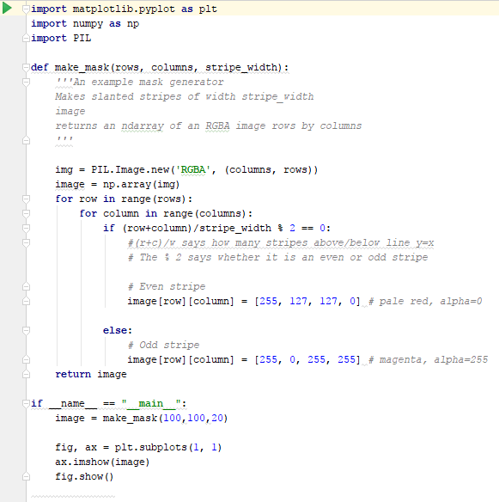

**Conclusion**

1. Describe what the data in a digital image contains, and describe what it means if a digital image has been “altered.” The data in a digital image is comprised of RGB(A) pixels that support three different color intensities. When an image is “altered,” certain pixels of that image have been edited via distortion, enlargement, contraction, etc.
2. What are some of the differences between a photograph taken with light-sensitive film and a photograph taken with a digital camera? In what ways are they the same? A series of photographs taken with a light-sensitive film camera must be stored on multiple rolls of film whereas photos recorded with a digital camera can usually be stored in one location (e.g., CF cards, cloud, file directory, SD cards, etc.). However, film cameras can capture and in some cases exaggerate the quality of lighting whereas digital cameras retain the image itself without extra lighting effects, although, those can be added later.

<https://digital-photography-school.com/film-vs-digital/>

1. There are ways to send secret information in photographs using the lowest-place-value bits in each color byte. Concealing information in an image is called steganography (i.e., a field within cryptography; uses images to hide data). The 1s place and 2s place of each RGB pixel intensity could be changed to encode the numbers 0 to 63, more than enough for the alphabet.
2. If you google “Python image analysis,” you can find several Python libraries that will analyze an image. At least one library has a method or function that can determine how many separate objects are in the image. In very rough terms, describe how you think such an algorithm might acquire this information from the RGB pixel values. Theoretically, the algorithm would acquire the numerical RGB values of the pixels and manipulate them according to the user.

**PLTW Activity 1.4.4**

**Notes**

A portion of a software developer’s job revolves around implementing other individuals’ code aka “copy and paste coding” according to Mr. Greenway.

An Application Programming Interface (API) is the way programmers communicate and simplify their code with other programmers. In object-oriented (i.e., a paradigm for programming in which code describes a class with methods, including a method for creating an object in the class) libraries, an API specifies the methods of each class.

An object is a specific instance of a class with a specific set of values for its own attributes that can execute any methods defined in its class. Attributes are data associated with an object and methods are sets of instructions that are grouped together to perform something pertaining to an object. A class is an abstraction defining an object with methods and attributes. An instance is a single object of a specific class.

Instantiation is the process of creating an object, an instance of a class, which generates space in memory for the new object and binds a name for the object with the object's data in memory. Constructors are a method for creating an object in a class.

The four kinds of documentation are: official documentation, third-party documentation, tutorials, and problem/solution-specific documentation, often in social formats such as Stack Overflow.

The official documentation is usually among the best references for using a library of code. Official documentation is produced by the person or group who created the code. Docstrings fall into this category since they are created by the developers while commenting in their code. A bounding box is a rectangle that closes part of an image.

**Journal**

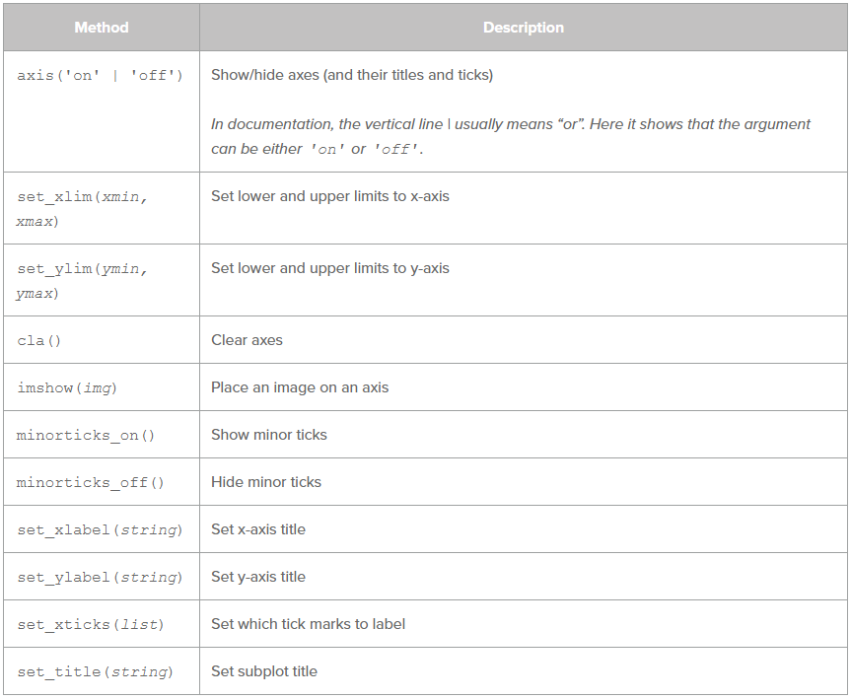

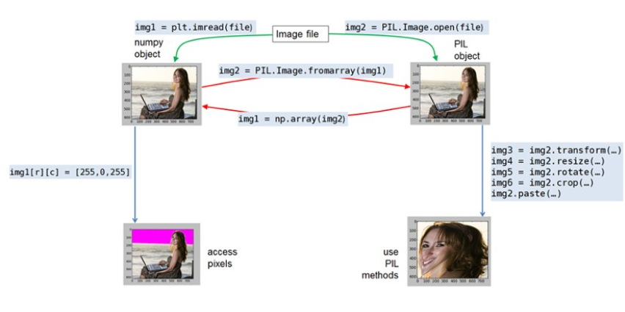

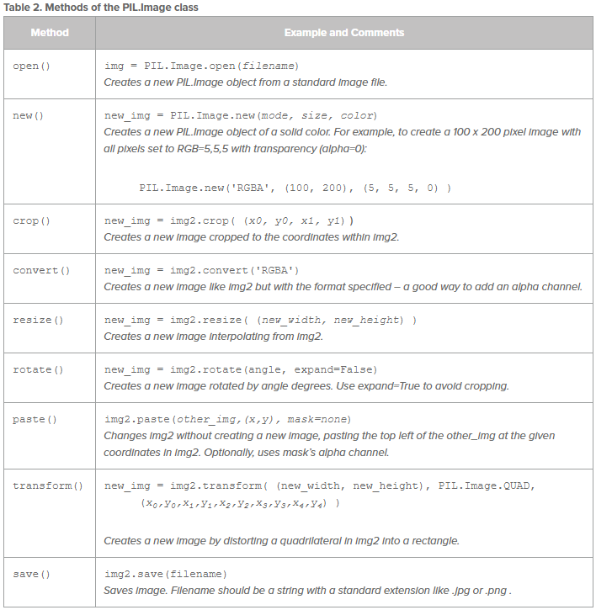

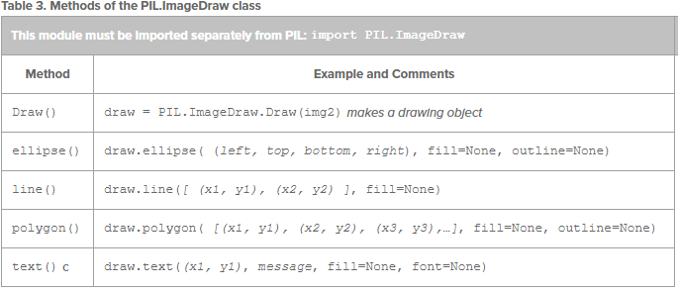

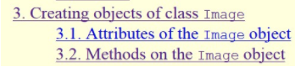

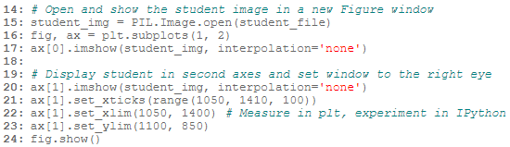

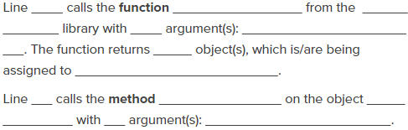

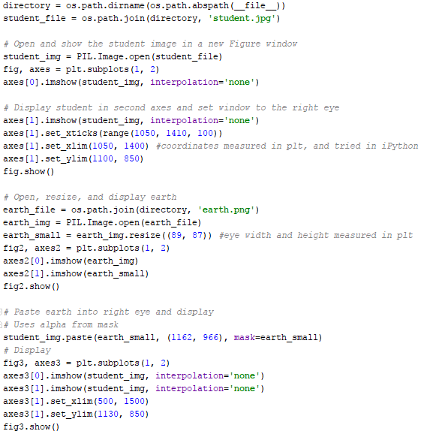

**Conclusion**

1. Describe the classes, methods and attributes used in code in this lesson.
2. Consider the statement—Abstraction is a strategy for handling complexity.

By giving a name to a complex task and encapsulating the details inside that method. Describe a complex computational task you performed in this activity.

**PLTW Activity 1.4.5**

**Notes**

An exception is an error or other message raised by the interpreter or compiler to indicate a special circumstance that should be quelled by an exception handler. If an exception is not processed, the program will stop and report the error. A handler is an event such as mouse input in a graphical user interface, or such as an error or exceptions, that triggers the execution of an event handler or exception handler.

A traceback is a list of function calls that were made before an exception stopped the program.

The try statements are executed one at a time. If one of those statements causes an error, the interpreter checks to see if the type of error matches the type of errors listed in the except statement. If the error type matches the except statement, then the interpreter does not execute the rest of the try block and instead proceeds with the except block of code. If the error does not match the except statement, then the error is not caught and the program will be halted.

**Journal**

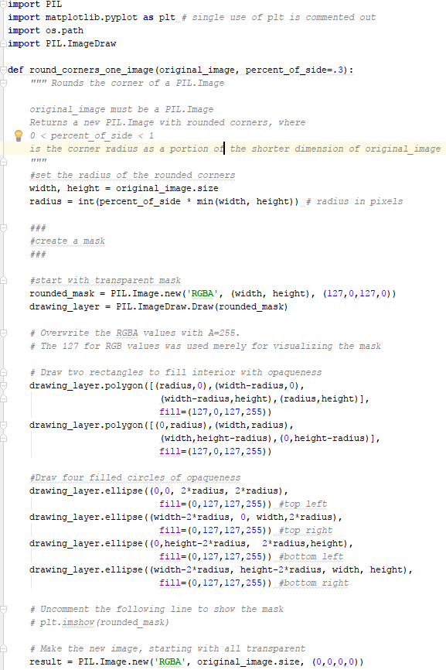

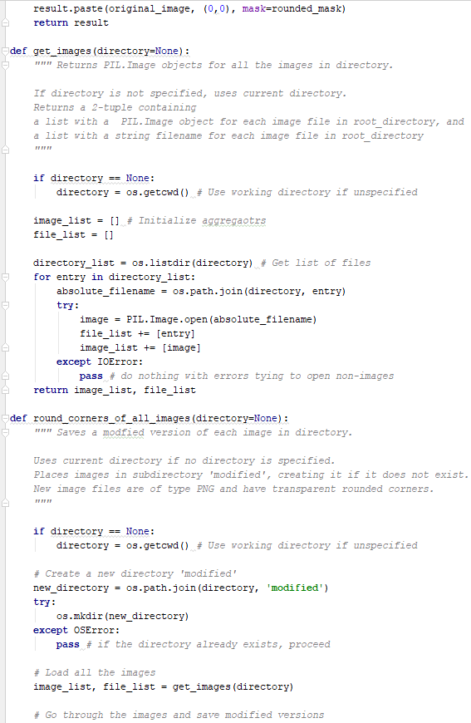

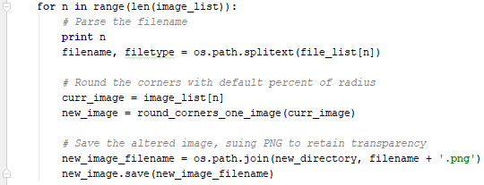

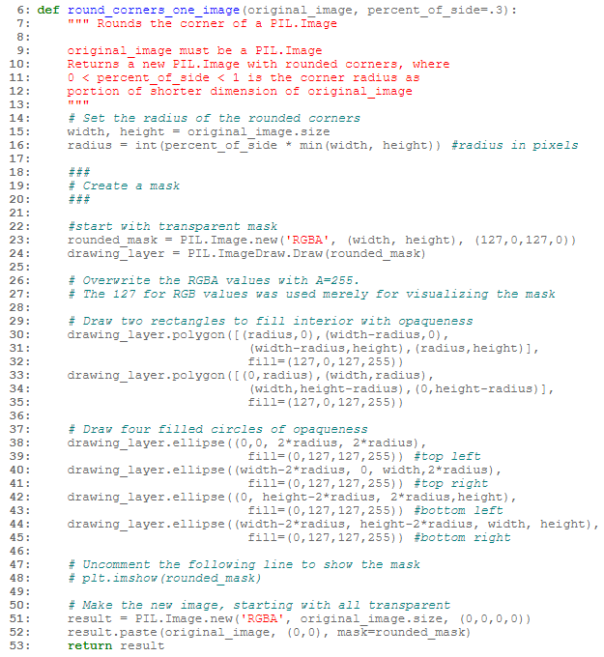

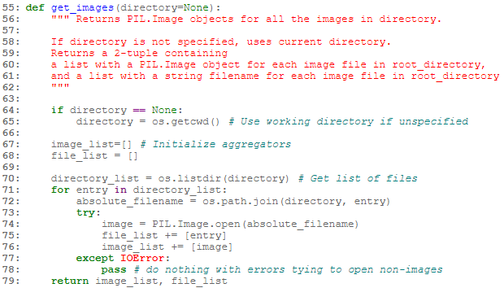

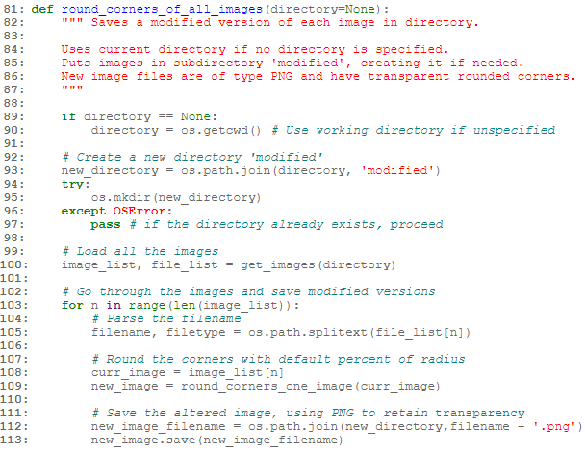

**Conclusion**

1. Icons on the desktop are not usually rectangular. You can see through the desktop behind their irregular edges. How is this accomplished? This is accomplished by simulating transparency—the icon may raise the color values of the intersecting pixels of the desktop.
2. You have 2000 images and would like thumbnails of all of them so that they will be transparent in their corners. Describe the algorithm you would use to accomplish this. Hypothetically, you could create an algorithm that converts the images to “.ico” files and removes the edges of the images, making the pictures circular.
3. The code provided was divided into three functions. Describe how this made the code reuse easier. Since the code was divided into three separate functions, copy and pasting is easier as you can pick and choose which functions you want to implement.

**PLTW Activity 1.4.6**

**Notes**

Metadata is information about data, such as when, how, or by whom the data were collected or what software was used to manipulate the data. Metadata is accessible to the computer, the software it runs, and the individuals who know how to read it.

The creative commons licensing is as follows: CC-BY—you can use or modify this work, but credit who the work is by, CC-ND—you can use this work but not modify it; no derivatives, and CC-NC—you can use this work but cannot sell it; non-commercial use.

**Journal**

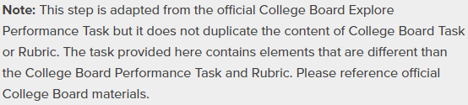

**Conclusion**

1. How did you feel about digital privacy before this activity? How has your understanding of digital privacy changed? My understanding of digital privacy has not been altered as I have always known that technology can be utilized for nefarious purposes, hence the Russian involvement in the election of 2016.
2. How did you feel about copyright law before this activity? How has your understanding of copyright law changed? Copyright laws were instated to prevent the exploitation and illegal redistribution of a software developer’s work. My understanding of copyright law has not changed.

**PLTW Activity 1.4.7**

**Notes**

None for this section.

**Journal**

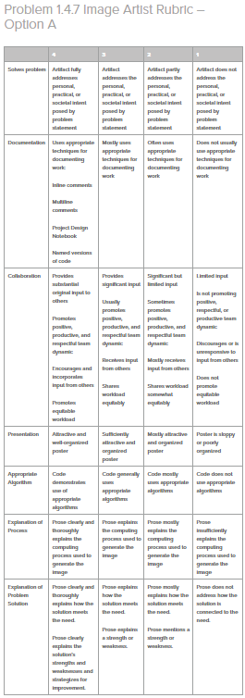

<https://pltw.read.inkling.com/a/b/6a898c91765d4fad9eec30d5c213823e/p/c97ca4be21154398b779b037c6a08d5c>

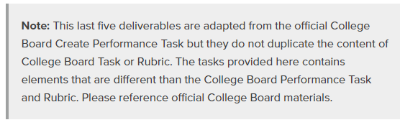

**Conclusion**

1. Alice and Barb have different ideas about what a “manipulated image” is. Decide whether you think that each of them is right, wrong, or somewhere between. Write an argument in support of your ideas.
2. Alice: “All images are manipulated. For one thing a camera is sensitive to certain kinds of light and the developer controls the exposure level. Even our human eyes have a limited number of pixels! There are ‘only’ 120 million rods and 6 million cones in each retina, so our vision is pixelated just like a digital image. And our vision is also highly processed – even the blind spot in each eye gets filled in. Out of all those millions of light detectors, only about 1 million ganglia neurons go from the eye to the brain. There is no such image as seeing the ‘real’ thing.”

Barb: “Of course there is a real image. Certain kinds of manipulations are accurate and others tell lies.”

Under what circumstances is an image yours to use? Yours to distribute? Yours to sell? Write about your thoughts on this question in the context of downloaded images and images you take with a camera.

1. Reflect on the team dynamic and on the design process. What were areas for improvement? What steps could you take next time to make those improvements?